CUSTOM BPM PORTAL

# Introduction

This portal is developed using node js and express js technologies. You can download this application and extend, add new features. This portal communicates with IBM BPM using REST API. If you have any questions please contact me at harishfysx@gmail.com.

# Installation

## Pre-requirements

To use this application make sure you have following installed on your machine.

1. IBM BPM Process Center , Or Process Server Version 8.5.6
2. Node JS
3. Git
4. NPM

### Node JS & NPM Installation Procedure

1. **Download the Windows installer from the**[**Nodes.js® web site**](http://nodejs.org/)**.**
2. **Run the installer** (the .msi file you downloaded in the previous step.)
3. **Follow the prompts in the installer** (Accept the license agreement, click the NEXT button a bunch of times and accept the default installation settings).

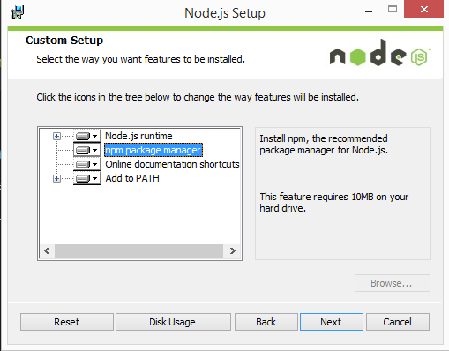

1. **Restart your computer.** You won’t be able to run Node.js® until you restart your computer.

Make sure you have Node and NPM installed by running simple commands to see what version of each is installed and to run a simple test program:

* **Test Node.** To see if Node is installed, open the Windows Command Prompt, PowerShell or a similar command line tool, and type node -v. This should print a version number, so you’ll see something like this v0.10.35.
* **Test NPM.** To see if NPM is installed, type npm -v in Terminal. This should print NPM’s version number so you’ll see something like this 1.4.28
* **Create a test file and run it.** A simple way to test that node.js works is to create a JavaScript file: name it hello.js, and just add the code console.log('Node is installed!');. To run the code simply open your command line program, navigate to the folder where you save the file and type node hello.js. This will start Node and run the code in the hello.js file. You should see the output Node is installed!.

### Installing GIT

An easy way to get Git installed is by installing GitHub for Windows. The installer includes a command line version of Git as well as the GUI. It also works well with PowerShell, and sets up solid credential caching and sane CRLF settings. We’ll learn more about those things a little later, but suffice it to say they’re things you want. You can download this from the GitHub for Windows website, at[http://windows.github.com](http://windows.github.com/).

## Installing NODE-JS Portal

Once node-js is installed, please clone the project on your local machine

Using following command

git clone <https://github.com/harishfysx/BpmCustomPortal2.git>

This will clone the project on your local machine.

Now cd to that directory

And type command ‘npm install’. This will install all the dependent software modules on your local machine.

The cloned project will look like following

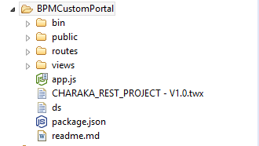

### Configuration

1. Import [CHARAKA_REST_PROJECT - V1.0.twx](https://github.com/harishfysx/BpmCustomPortal2/blob/master/CHARAKA_REST_PROJECT%20-%20V1.0.twx) in the process center.
2. Create Necessary Groups in the Process Admin Console. In this application we are using following BPM Groups and Teams. Plese create groups in the process admin console. And add test users in each group.

|  |  |  |
| --- | --- | --- |
| BPM Group(In Process Admin Console) | Team (In CHARAKA_REST_PROJECT) | Members |
| PCP_FrontDesk | **FrontDeskTeam** | **pcp_test_frontdesk1,**  **pcp_test_frontdesk2,**  **pcp_test_frontdesk3,**  **pcp_test_frontdesk4,** |
| PCP_Nurses (Group) | **Nurses** | **pcp_test_nurse1,**  **pcp_test_nurse2,**  **pcp_test_nurse3,**  **pcp_test_nurse4,** |
| PCP_Physicians | **Doctors** | **pcp_test_doctor1,**  **pcp_test_doctor2,**  **pcp_test_doctor3,**  **pcp_test_doctor4,** |

|  |  |  |
| --- | --- | --- |
| PCP_LabTechnicians | **LabTechnicians** | **pcp_test_labtech1,**  **pcp_test_labtech2,**  **pcp_test_labtech3,**  **pcp_test_labtech4** |

1. Go to Rest Tester of your Process Center. The login url for this console is https://<Process server host>:9443/bpmrest-ui/login.jsp
2. Search exposed processes. (Make sure you logged in with the PCP_Front_Desk) group member.

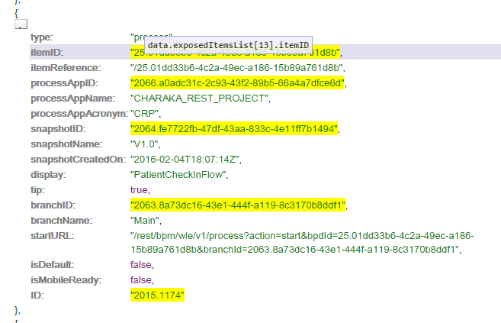

1. In the clone project folder change the values in the route/config.js file according to your environment

baseUrl: < your process center’s >

bdpId: < Which you get it from exposed process –above step)>

branchId: < Which you get it from exposed process –above step)>

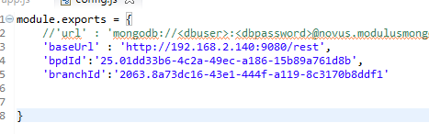

1. Now start the application by typing ‘npm start’ in the cloned project folder. You will get the out put as shown in the following picture.

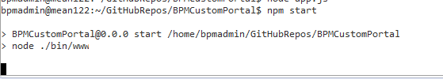

Now go to http://192.168.2.122:3000/ in your browser. You should see log in screen. This means you successfully installed the Node-JS Process portal for IBM BPM on your machine

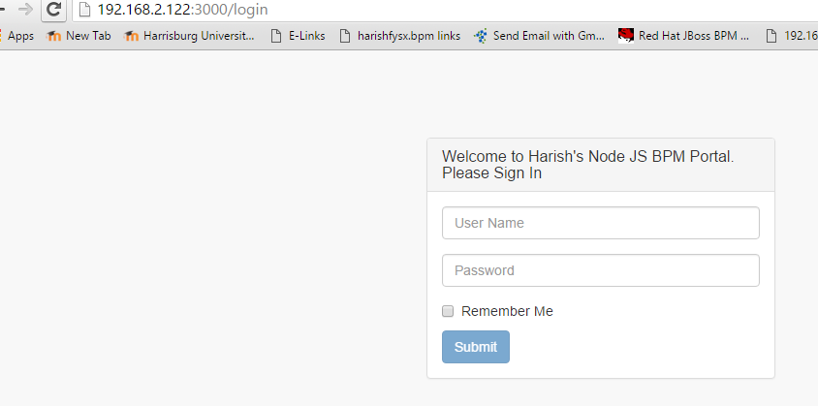

# TESTING NODE JS PORTAL

## Creating process instance

As specified in the CHARAKA_REST_PROJECT, the Front Desk Team member will be able to start the process instance. So log in as front desk team member.

In my case I am logging in as pcp_test_frontdesk1

To kick start the process you need to fill the patient details. Please notice the validations implemented with Bootstrap validator frame work .Once you fill all the details click on submit button. This will starts the process and assign the task to the front desk team. You can check this in the process inspector.

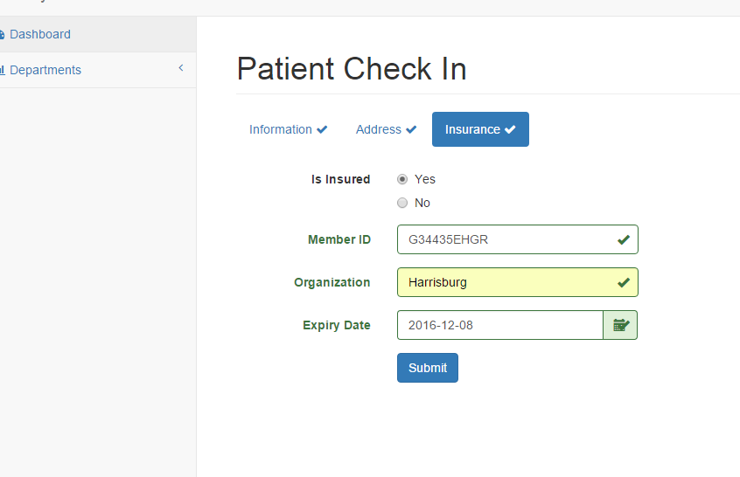

Now go to Front Desk-send to Nurse Page in the navigator. You can search for the tasks assigned to front desk team as well the user logged in. You can see the Normal Priority Tasks and Highest Priority tasks were only implemented here.

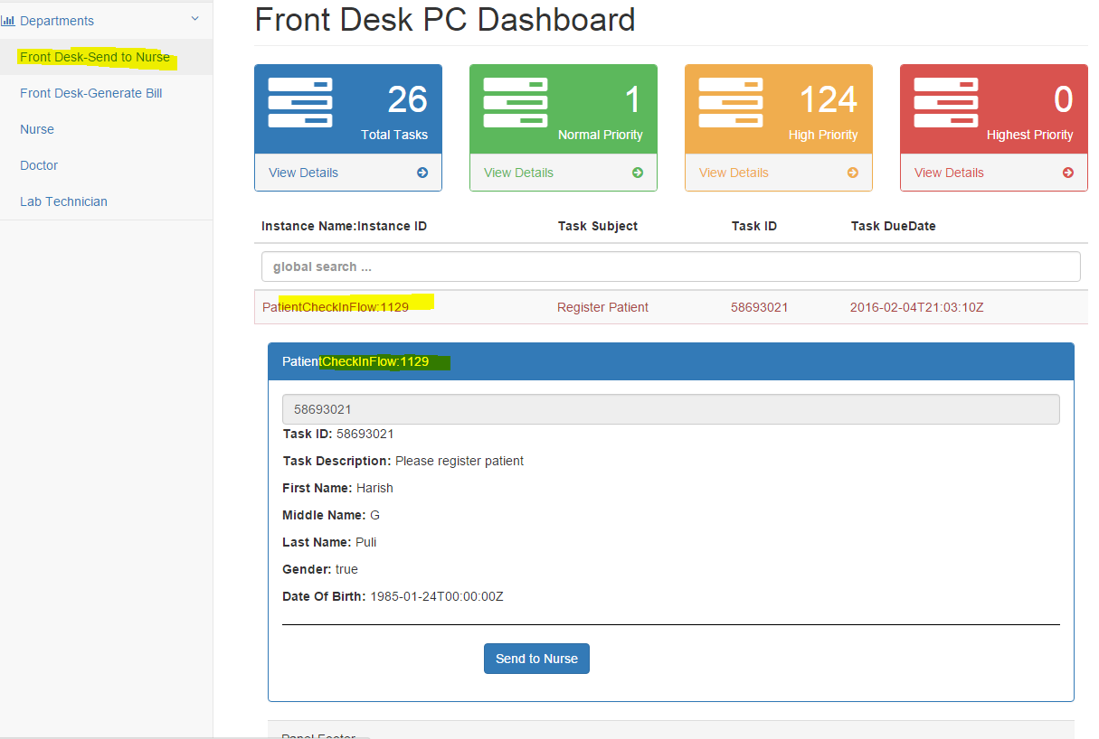

In the inspector view

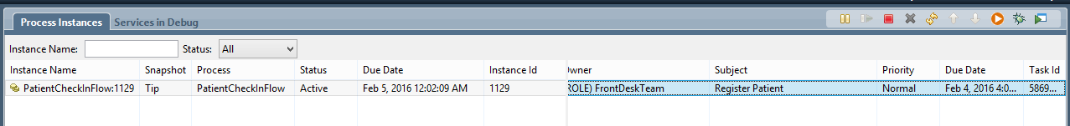

## FRONT DESK SEND TO NURSE

To assign the patient to the Nurse click on Send to Nurse button(Make sure you are still logged in as front_desk team member)

This closes the task and creates new task to the Nurse.

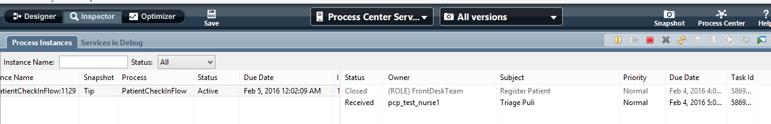

As you can see in the inspector view the task is created for pcp_test_nurse1 user

## NURSE

Now log in as nurse and see the tasks assigned in the smart-table. You can pefrom global search on this table. Fill the vital parameters and click on submit. This will close the current task and creates new task for the doctor.

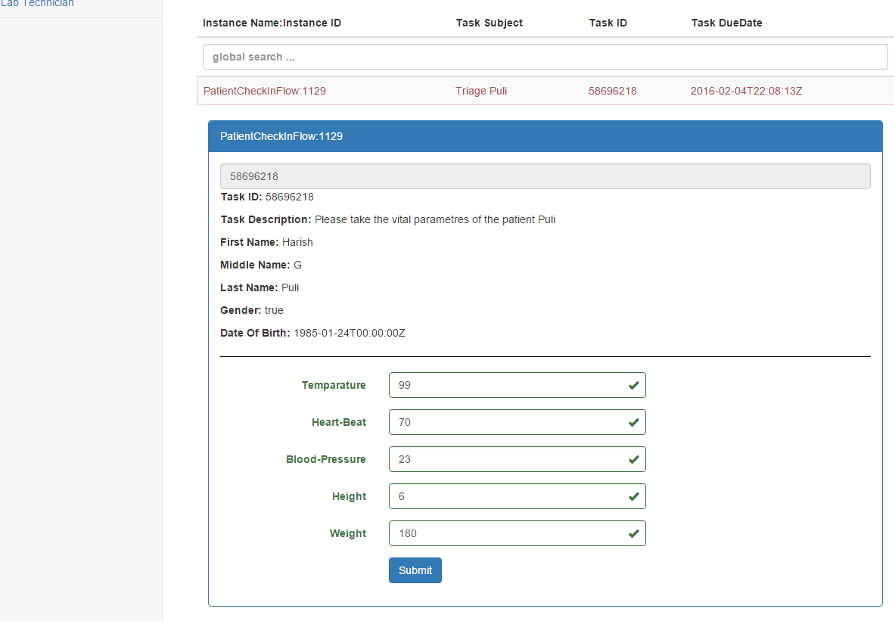

In the process inspector

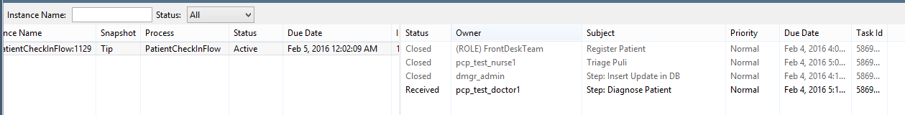

## Doctor

As you can see in the process-inspector the task is created for pcp_test_doctor1. Log in as that user and perform the task.

In this screen you can see the table with add and remove button is implemented and all the data from Front Desk & Nurse tasks were carried forward to the doctor’s task. In the background we implemented BPM REST API.

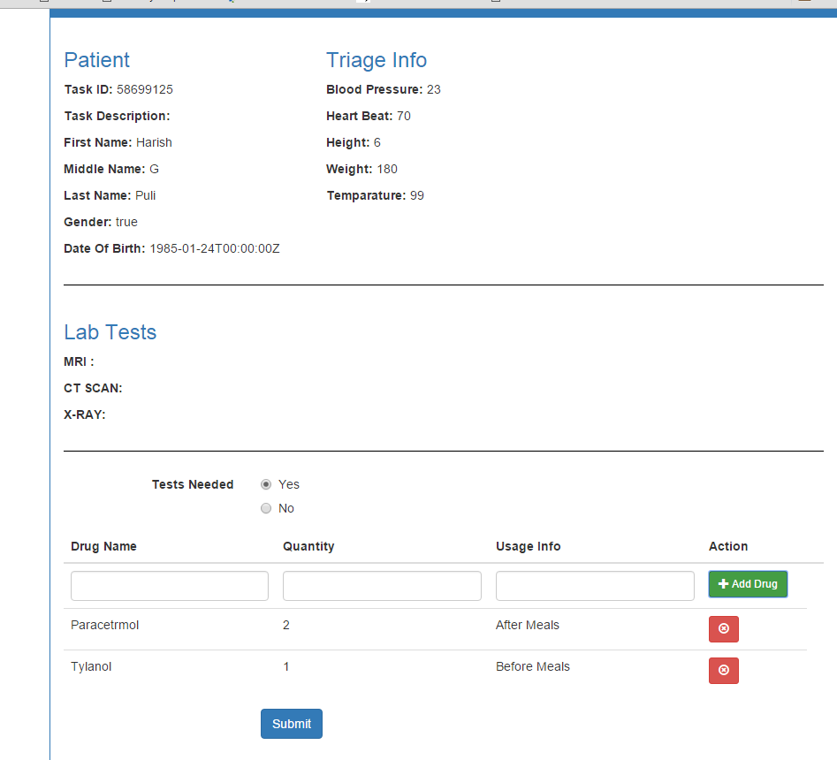

Once you submit task , the task can go either to Lab Technican team or to Front Desk team depending on Tests Needed Flag.

Lets assume no tests are needed in this case. Then the task is routed to front desk team.

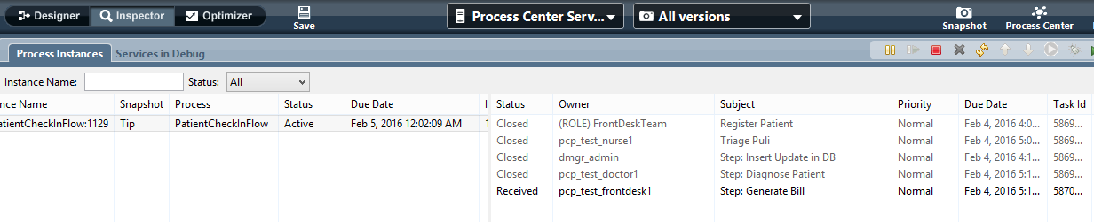

## FRONT DESK –GENERATE BILL

Log in as front desk team member In this screen we will show all the details filled by all departments. When the front desk team member clicks on the “Dispatch’ button, the flow ends.

